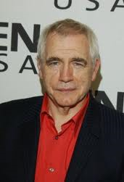  Hermann Goering: Hitler’s Second in command. He signed several documents in support of Hitler and his “Solution” for the Jews. He is considered to be the perfect example of how the Nazi’s refused to take responsibility for what they had done. Found guilty on the following accounts; Conspiracy to commit crimes,  Crimes against Peace, War Crimes, and Crimes against Humanity. Committed Suicide by inhaling cyanide two hours before he was supposed to be hanged for his crimes. (actor) | 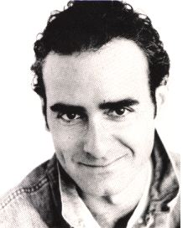  Rudolf Hess: Deputy Führer and considered to be the number 3 man in Hitler's Germany after Göring. In the courtroom, he suffered from spells of disorientation, staring off vacantly into space and for a time claimed to have amnesia. In spite of his mental condition, he was sentenced to life in prison. He committed suicide in 1987 at age 92, the last of the prisoners tried at Nuremberg. (actor) |  | 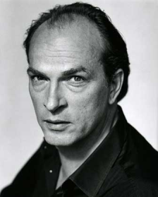  Albert Speer: An architect who served Hitler faithfully and helped keep the German War Machine going extending the war and continuous murder of Jews by one year. Towards the end, he began to see Hitler as crazy and disturbed as Hitler wanted to burn Germany to the ground rather than see it lose the war. Speer attempted to thwart these efforts. He was sentenced to 20 years (mostly due to forced labor accusations) in prison and died of natural causes in his mid 80’s. (actor) |  | 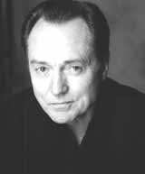  Hans Frank: Nazi’s chief legal counsel and Hitler’s personal lawyer. In Poland, Frank ordered the execution of hundreds of thousands of Poles, the enslavement of hundreds of thousands of Polish workers who were shipped to Germany, and the herding of most of Poland's Jews into ghettos as a prelude to their extermination. He was found guilty of war crimes and crimes against humanity and hung in 1946 after his trial at Nuremberg. (actor) |  | 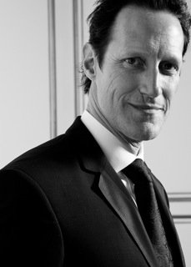  Ernst Kaltenbrun-ner: He was an SS commander and was in charge of an operation aimed at assassinating Churchill, Roosevelt, and Stalin. He was very close to Hitler and very powerful. Many feared his power, even Himmler. Through his command of the German SS he established concentration camps and ordered the execution of millions of Jews. He was convicted at the Nuremberg Trials and sentenced to hang. He was hung in 1946. (actor)
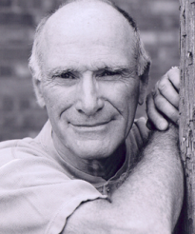  Wilhelm Keitel: He was one of Adolf Hitler’s leading generals in World War Two. Keitel was also responsible for signing a number of military orders that broke the accepted conventions of warfare. One was that captured French pilots fighting for the Red Army should be shot rather than being treated as POW’s. During the trial, he claimed that he was simply following orders as any good soldier would. The claim was rejected and he was found guilty on all charges and sentenced to death. (actor) | 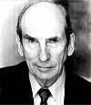  Franz von Papen: He served as Chancellor of Germany in 1932 and as Vice-Chancellor under Adolf Hitler in 1933–1934. At the Nuremberg Trial, he was accused of “political immoralities” such as disrupting relations with the Soviet Union and Turkey but found not guilty by the tribunal. He was sentenced to eight years in prison and was released in 1949. He wrote a number of books defending his policies and died in 1969. (actor) |  | 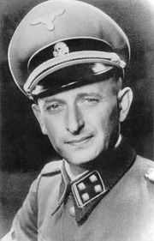  Adolf Eichmann: One of the major organizers of the Holocaust. He participated in the conference surrounding the Final Solution to the Jewish Question and organized for the deportation of Jews and the set up of various concentration camps in Nazi Germany. He escaped to Argentina after the war. Where he hid his identity and worked for Mercedes-Benz until 1960 until he was captured by the National intelligence Agency of Israel. He was tried and convicted of war crimes and crimes against humanity. He was hung in 1962 in Israel. (real guy) |  | 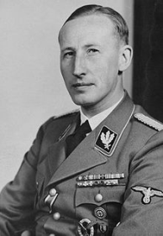  Reinhard Heydrich: High Ranking Nazi General who chaired the Wannsee Convention (from the film Conspiracy) which laid plans for the Final Solution for the Jewish Question. He was killed in 1942 well before the Nuremberg trials and then end of the war. He was attacked by Special Operations Officer, who chosen specifically to assassinate him, in Prague. They threw a bomb at his car and Heydrich died of his injuries. As a result, Heinrich Himmler mistakenly linked the assassins to the town of Lidice sent 1300 people to concentration camps and the town was demolished. (real guy) |  | 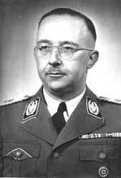  Heinrich Himmler: A Nazi military leader who oversaw all of the Gestapo and all concentration and death camps. He coordinated the killing of millions of Jews along with thousands of gypsies, Poles, homosexuals, communists, people with disabilities, and anyone else deemed unworthy to live. He was arrested by British forces in May of 1945 after surrendering Germany. He committed suicide the day after he was captured and before he could be questioned. (real guy)
Conspiracy: To plan unlawfully and treacherously. An agreement between two or more people to commit a crime or other wrongful act. Think about the Wannsee Conference. |  | Crimes Against Peace: The planning, preparation, or initiation of aggressive war in violation of national treaties and agreements. Think about the Germany’s invasions into various countries as Hitler gained land and power in the beginning of the war. |  | War Crimes: Violations of laws or customs of war including (but not limited to) murder, ill-treatment or deportation of slave labor or prisoners of war, killing of hostages, and the destruction of cities not justified by military necessity. |  | Crimes Against Humanity: Inhumane acts committed against any civilian population before or during war. Also could include persecutions on political, racial, or religious grounds.
Significance/Reasons for Creating/Legacy of Nuremberg Trials:

Directions: Fill out the chart above.
- For the first half of the movie, you will focus on the significance of the Nuremberg Trials. Think about the reasons mentioned in the film. Why is this event so important? What are some of the reservations or worries about putting together a trial such as this? What gives this trial “weight” as opposed to past wars and attempts at international trials?
- For the second half of the movie, when the actual trial begins, you will focus on the four accounts charged against various Nazi Officials. Write down quotes from the film and your own reactions concerning these accusations brought on the Nazis.

